My 4-H Story Outline

- Who are you?
  - Introduce Yourself

  - Hobbies

  - How long you’ve been in 4-H?

- What did you do this year in 4-H?
  - Share the different projects or activities completed with 4-H

  - Did anyone help you in your 4-H journey?

- What did you learn this year?
  - How has 4-H made a difference in your life?

  - What did you learn this year that makes you a better person?

  - How did the project you completed help you grow?

- What did you enjoy this year?
  - Share any moments or things you enjoyed this year

- What are your goals in life?
  - What do you hope to accomplish in the future?

** Be sure to capture how you’ve grown in your project area. **

4-H Project Focus

What’s your project focus?

What did you do in this project this year and when did you do it? Be specific! List the most important presentations, talks, exhibits, camps, judging events, workshops, or any other learning experiences in which you have participated related to your project.

What did you learn?

4-H Photos & Supporting Materials: Caption That!

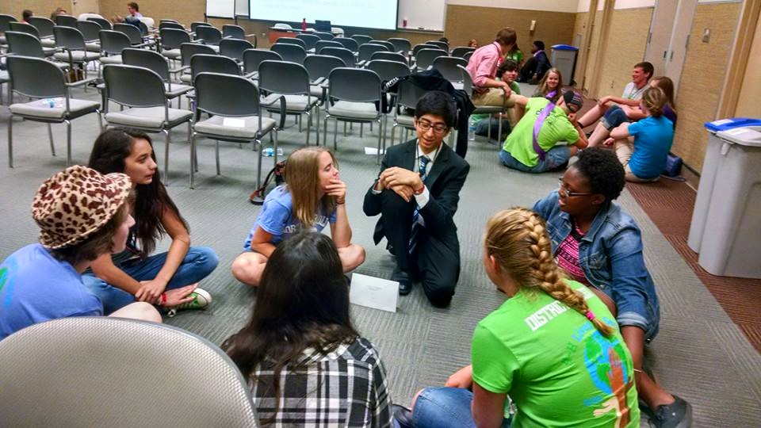

Caption That:

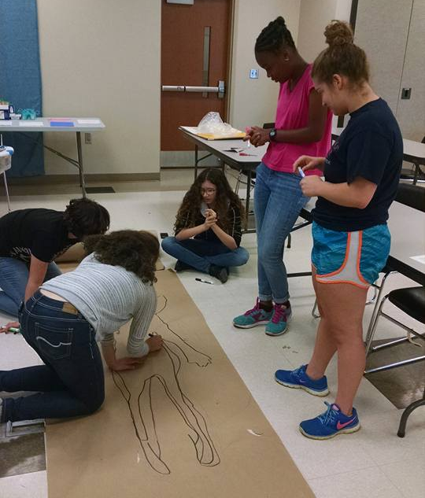 Caption That:

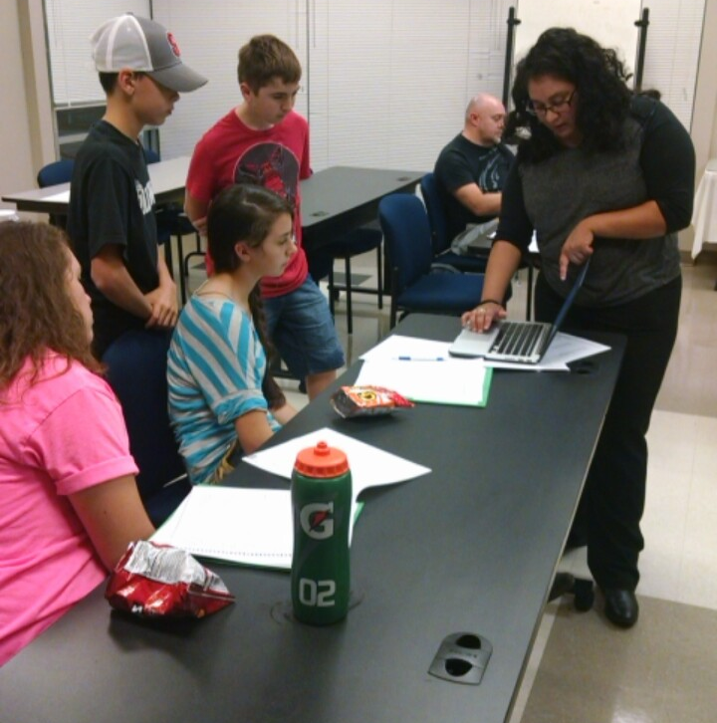 Caption That:

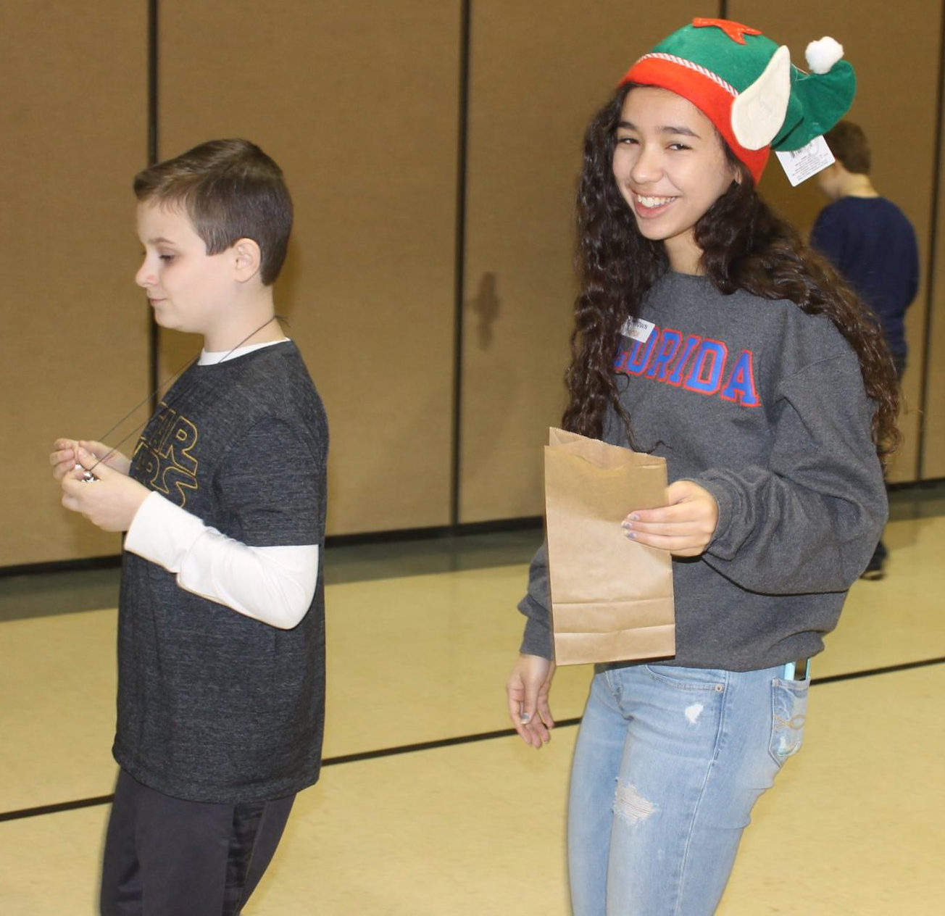
Caption That:

4-H Goal Setting

Action | Results | Timetable

