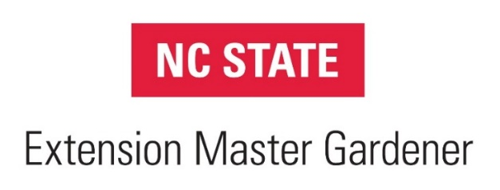

NC State Extension Master GardenerSM Program Student/Intern Code of Conduct Form

We appreciate your interest in the NC State Extension Master GardenerSM (EMG) program. Your satisfaction and progress in this volunteer position is important to us. Master GardenerSM volunteer (MGV) student/interns must sign this form and file it with the local Extension center to be eligible to participate in the EMG training and to be covered by NC State University liability protection plan.

By signing this form, you are agreeing to abide by all items in this agreement, as well as all program policies and procedures covered in the NC EMG Program Guidelines, available at go.ncsu.edu/emg-guidelines. Volunteers not adhering to all items in this agreement and within the Guidelines may forfeit their ability to participate in the EMG program.

As a student and intern in the NC State Extension Master GardenerSM Program, I agree to do the following:

- Participate fully in the training program provided for N.C. Master Gardener volunteers.
- Complete the 50 hour volunteer service internship within one year of completing the training program.
- Abide by the NC State EMG Program Guidelines and the following Code of Conduct:
- I will perform my duties with dignity and pride as a representative of NC State University, follow University and county policies, and work under the supervision of an NC State or NC A&T University employee.
- I will respect and interact in a professional manner with paid staff, volunteers, and clientele. I will be a positive role model, refraining from profanity, harassment, disruptive behavior, or abuse of any kind.
- I will perform assigned duties without financial compensation or workers’ compensation coverage. I will not accept personal payment for speaking engagements or other activities performed as a Master GardenerSM volunteer.
- I will provide unbiased, research-based information consistent with NC State University recommendations.
- I will make no recommendations or endorsements of a particular product or place of business. Nor will I use my title as a Master GardenerSM volunteer for commercial or private business.
- I will provide cultural, mechanical, biological, and chemical recommendations to clientele so that they can make an informed decision about integrated pest management.
- I will restrict my chemical pesticide recommendations to only those in the North Carolina Agricultural Chemicals Manual, recent Extension publications, or pesticide labeling. I will encourage clients to read the pesticide labeling themselves rather than providing them with dilution or application recommendations.
- I will restrict my answers to questions within my area of expertise or training. I will not answer questions concerning household pests, commercial horticulture, herbicide damage, hazardous tree evaluation, medical or legal questions, or determining if a questionable plant or mushroom is edible.
- I will submit written materials that I prepare (news articles, news releases, newsletters, leaflets) for review and approval by the Extension agent or the appropriate subject matter Extension specialist or state EMG program coordinator prior to printing.
- I will refer requests for information by newspaper reporters to the Extension agent.
- I will refer possible poisoning cases to the Carolina's Poison Center (800-848-6946).
- I will wear my EMG nametag when doing volunteer work for Extension.
- I will dress in an appropriate and professional manner suitable for the activity or location I am participating in. “Office casual” is appropriate for speaking engagements, indoor plant clinics, and schools. Gardening work clothes are appropriate for working in demonstration gardens and some outdoor events.
- I will maintain a neat and clean appearance that is appropriate for the workplace setting and for the work being performed.
- I will not make copies of copyrighted material for distribution without written permission from the copyright owner.
- I will not sign contracts on behalf of Extension or the EMG program.
- I will not display discriminatory behavior (based on race, color, religion, sex, age, national origin, handicap, and sexual orientation), engage in sexual harassment, alcohol or drug use, or carry a dangerous weapon while serving as a Master GardenerSM volunteer.

I have read and agree to abide by the EMG Program Guidelines and Code of Conduct regarding my service as a Master GardenerSM volunteer.

Date: __________________________
MGV Student/Intern Signature: ______________________________________________
Printed Name: ____________________________________________________________
AG-799 Last updated Dec. 18, 2018

